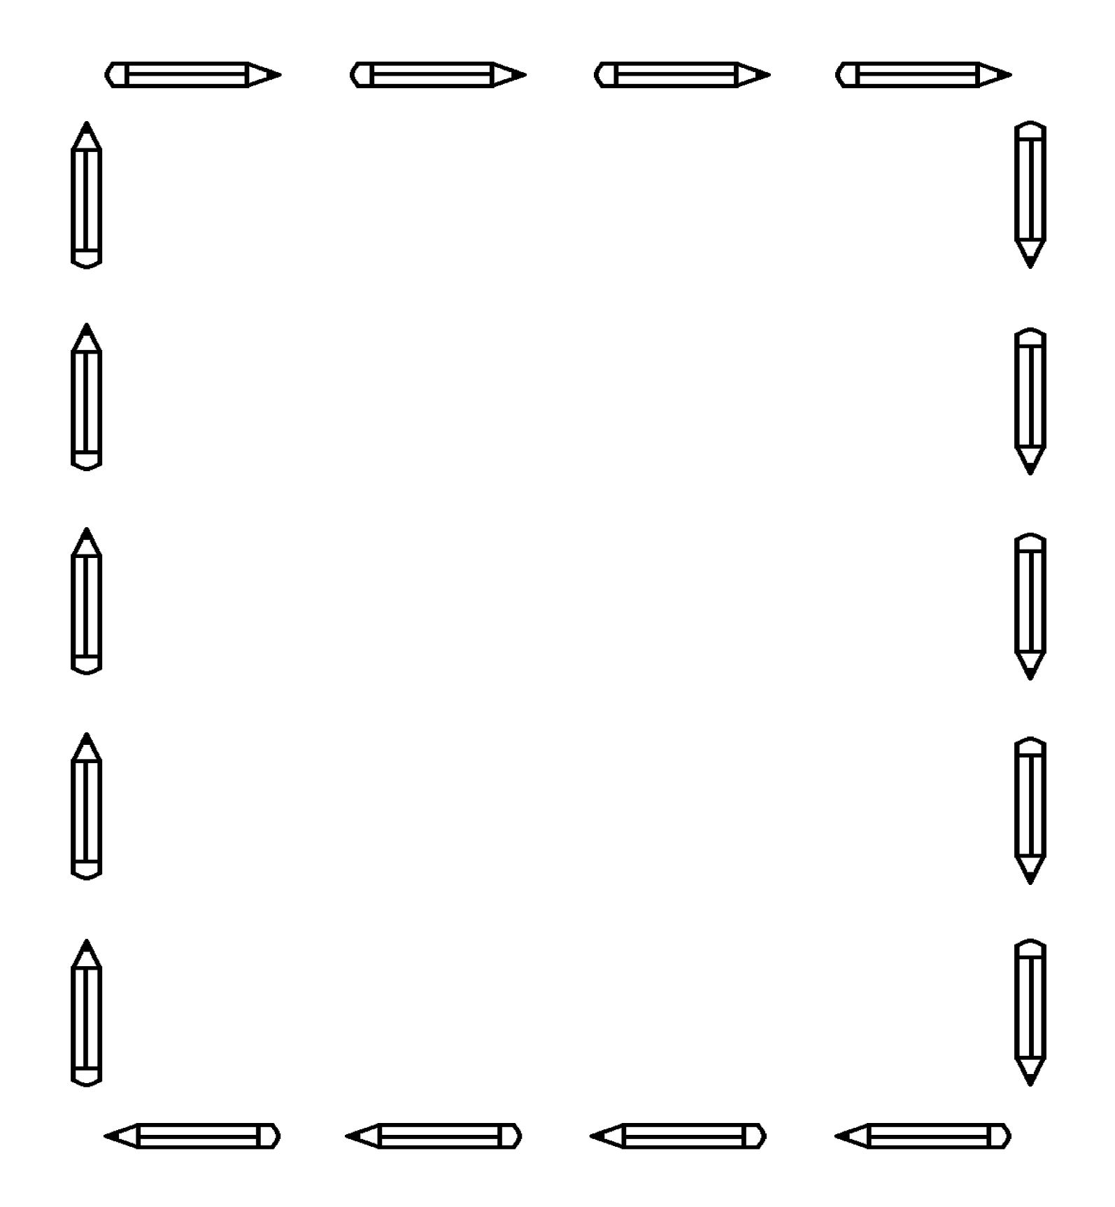

* ***Please write your child’s name on each item***
* One regular backpack (no wheels, please)
* $7 for weekly magazine (Please send the money in your child’s folder so the teacher can order the magazines for the whole class.)
* 4 sturdy plastic two-pocket folders (1 red, 1 blue, 1 green, 1 black)
* 1 small plastic pencil case (small enough to fit inside your child’s desk)
* 24 #2 pencils with erasers
* 5 dry erase markers (black, blue, or green)
* 6 pink erasers
* 1 package of 3 X 5 index cards (100 cards)
* 3 boxes of crayons (12 in each box)
* 5 glue sticks (Staples or Elmer’s brand)
* Scissors
* headphones (for using the computers in school, no earbuds please)
* shoelace locks (to keep shoelaces tied)

Supply List

First Grade

*General Classroom Supplies*

* 2 rolls of paper towels
* 3 boxes of facial tissue
* 1 box of baby wipes
* 3 containers of Clorox or Lysol wipes
* 2 bottles of hand sanitizer
* 1 box of gallon size plastic bags

*Thank you in advance for your help.*

*We are looking forward to a great year!*

September 2024